**Decision Problem:**

Given a graph G of connected shifts, and an integer K (number of employees), is there a valid shift allocation with no employees getting consecutive shifts?

#### Basic Definitions:

**Graph:** A graph G consist of finite set V and an irreflexive binary relation on V. The set V is called vertices and binary relation set is called edges.

**Irreflexive Property:** v is not R(v); for (v ε V). i.e. The relation is irreflexive if there is no relation (v,v) exist for all (v ε V).

**Stable Set:** A stable set is a subset X of vertices such that no two of which are adjacent. It is also called Independent Set.

**Proper K-coloring**: A proper k-coloring is a partition of the vertices V = X1 + X2 + ... + Xk such that each Xi is stable set. In such case, the member of Xi are painted with color i and adjacency vertices will receive different color.

**References:**

1. Martin Charles Golumbic and Werner Rheinboldt, *Algorithmic Graph Theory and Perfect Graphs*, ISBN: 978-0-12-289260-8
2. Melanie Mitchell, *An introduction to Genetic Algorithms*, MIT press

**Implementation Details**

# The problem is to decide whether the graph is proper k-colorable given input K. Following are the GA implementation approach.

### 1. & 2. Genetic Code & Gene Expression

Genetic code of a graph is represented as integer array where array index is vertex id and array value is gene (or vertex color or employees). The gene value is bounded by input k for deciding k-colorability.

### 3. Fitness Function

Given the candidate solution-employee shifts order(colors) for our graph, fitness function calculates number of non-conflicting edges. That is among the vertices which are connected with each other, how many of them are already properly allocated(colored) respect to each other.

**Screenshots:**

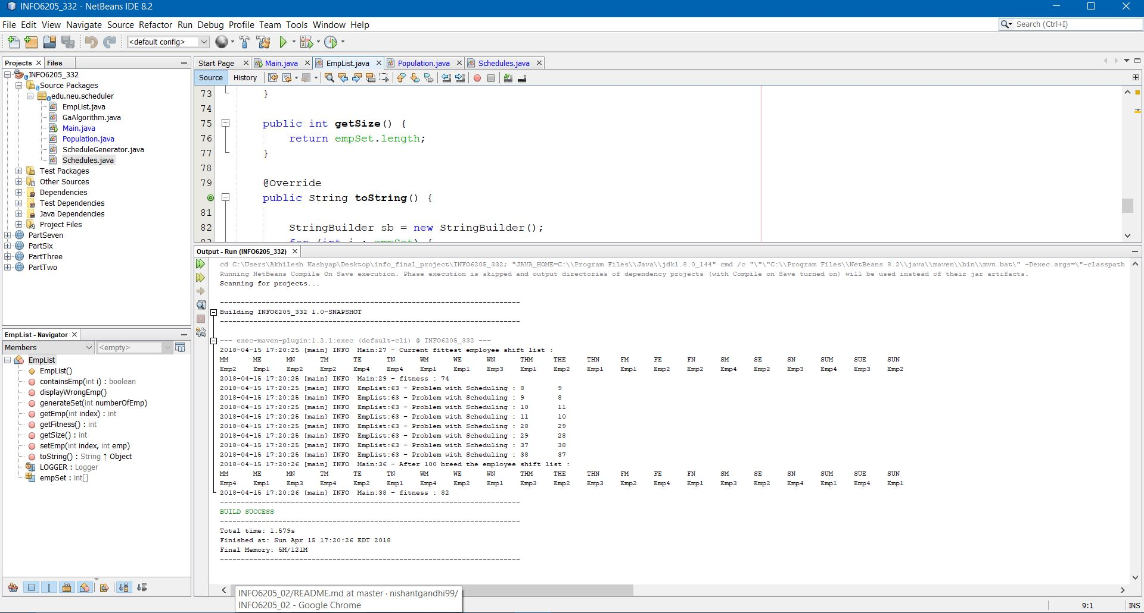

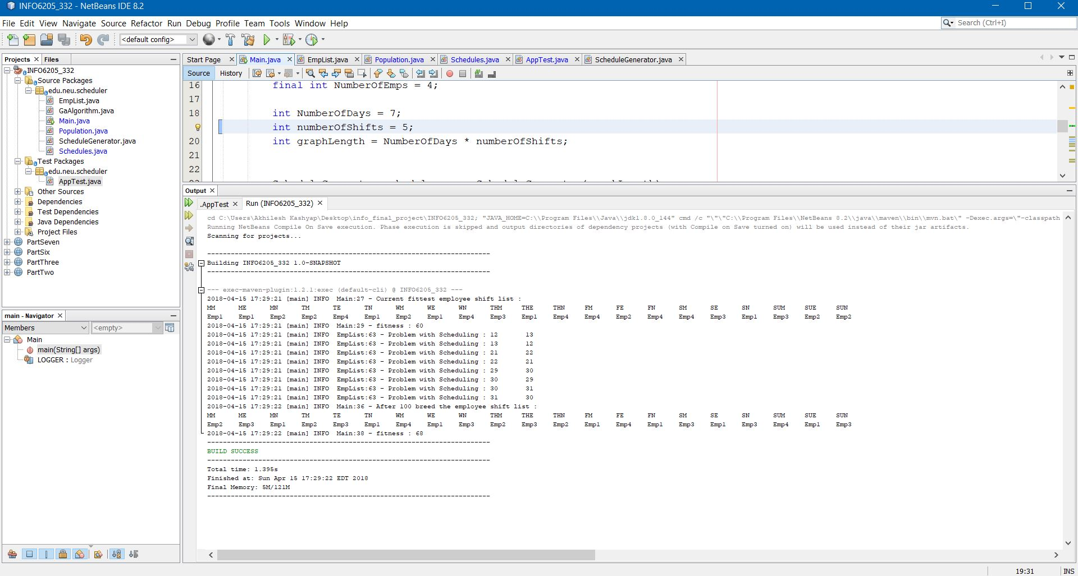

**Test Cases:**

